VOILE VIRTUELLE A L’UNSS

AVEC VIRTUAL REGATTA

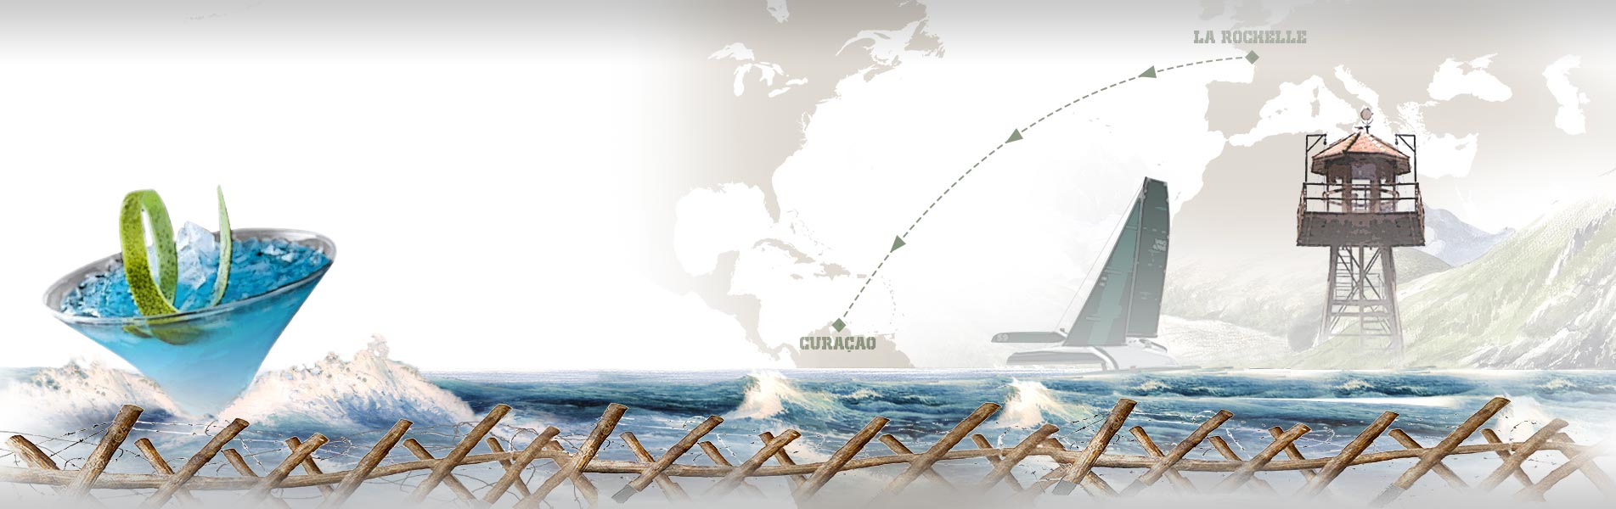

LA GRANDE EVASION CLASS 40
VIRTUAL REGATTA OFFSHORE :

https://www.virtualregatta.com/fr/offshore-jeu/

La FFVoile et Virtual Regatta ont ajouté des courses au programme normal des courses en mer. Actuellement se court la "Maitre Coq" et elle sera terminée d'ici un ou deux jours. Par contre ils ont ajouté 4 courses virtuelles :

"La Grande Evasion" qui se décline sur 4 supports: ULTIM, CLASS40, IMOCA et FIGARO. Le départ de ces courses sera donné dans 2 à 3 jours. L'UNSS demande aux AS et aux Licenciés qui souhaiteraient participer à une course virtuelle de s'inscrire sur la même course.

Nous avons choisi la course CLASS40. Elle dure à minima 18 jours. Il suffit pour cela de créer son compte, et de nommer son bateau avec UNSS en début de nom. Cette course part de La Rochelle et finit à Curaçao. C’est une course de 3900 Miles, soit 7223 KM. Son départ est fixé le 23 mars 2020 à 12h02.

VIRTUAL REGATTA INSHORE:

https://www.virtualregatta.com/fr/inshore-jeu/

La FFVoile et Virtual Regatta ont aussi conclu un accord pour que l’UNSS Nationale soit assimilée aux clubs de voile affiliés et puisse disposer d’un code d'activation pour créer ses propres régates, et ce autant de fois qu’il sera souhaité.

A ce moment là, un administrateur (que nous appelerons directeur de Course), ouvrira une ou plusieurs courses, collectera les noms et pseudos des comptes UNSS ouverts, et les invitera au départ de différentes régates successives en leur fixant les dates et heures.

Il sera nécessaire pour cela que les services UNSS, via les adresses mails de leurs animateurs d’AS, recensent les personnes intéressées (jeunes et adultes), et fassent remonter au Directeur de Course, les noms, adresses mails et pseudo de ces coureurs virtuels en demande.

A suivre,.... bien d’autres courses seront créer.

Bon vent à tous

CONTACT
FFVoile - Benoit CRESSENT : benoit.cressent@ffvoile.fr
UNSS - Didier POULMARCH : didier.poulmarch@unss.org

Si vous ne désirez plus recevoir ce type d'email, ﻿cliquez-ici﻿

